Many local Kids are Eligible for Free Health Care Coverage
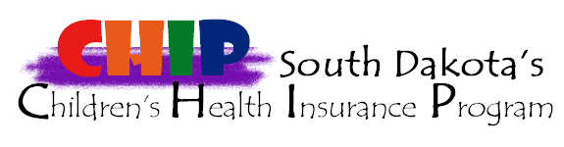

- MANY children in South Dakota’s classrooms who are uninsured are eligible for free children’s health insurance.
- Uninsured children are less likely to receive proper medical care for sore throats, earaches, and asthma —common childhood illnesses that are often the cause of school absence.
- One out of three uninsured children with recurring ear infections never sees a doctor during the year.
- One in five uninsured children has untreated vision problems.

Kids with health care coverage are better prepared to learn
As families get their children ready for a successful school year, we want to encourage parents to put enrolling for the South Dakota Children’s Health Insurance Program (CHIP) at the top of their back-to-school checklist.

South Dakota children under age 19 may be able to get free health insurance through the Children’s Health Insurance Program. Children enrolled in CHIP will receive coverage for doctor visits, hospital care, vision and dental care, eye glasses, prescriptions and other services. CHIP offers comprehensive coverage, much like many of the private health insurance programs.

Many families may not be aware that their children may qualify for coverage with CHIP. In fact, eligibility has been expanded to include many moderate-income families. Eligibility is based on family size and income. Larger families with higher incomes may also be eligible for the free health care coverage.

To find out if your child is eligible for free health care coverage or to apply for CHIP, contact your county social services office, go to http://dss.sd.gov/medicaid/generalinfo/medicalprograms.aspx#chip, call 605-773-3495, or call toll-free 1-800-644-2914.

